Chapter 9, Solution 45.

Find current I_{o} in the network of Fig. 9.52.

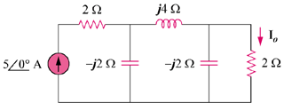
35∠0º A

Figure 9.52
For Prob. 9.45.

Solution
We obtain by applying the principle of current division twice.

I

I₂

Z₂

Z₁

(a)

I₂

I_{o}

2

-j2

(b)
,
–5 A

